GUIs for all UC

# 1. **Standardizing the screen configuration**

***Display***

Number of colors supported: 16,777,216 colors

***Screen***

Location of standard buttons: At the bottom (vertically) and in the middle (horizontally) of the frame

Location of the messages: Starting from the top vertically and in the middle horizontally of the frame down to the bottom.

Display of the screen title: The title is located at the top of the frame in the middle.

Consistency in expression of alphanumeric numbers: comma for separator of thousand while strings only consist of characters, digits, commas, dots, spaces, underscores, and hyphen symbol.

***Control***

Size of the text: medium size (mostly 18px). Font: Segoe UI. Color: #000000

Input check process: Should check if it is empty or not. Next, check if the input is in the correct format or not

Sequence of moving the focus: There will be no stack frames. Each screen will be separated. However, the manual is considered a popup message, as the main screen cannot be operated while the manual screen is shown. After the opening screen, the app will start with splash screen, and then the first screen (home screen) will appear.

Sequences of the system screens:

1. Splash screen (first screen)
2. Home screen
3. View cart screen – view items in the cart
4. Delivery form – fill delivery information
5. Update rush order delivery information
6. Invoice screen – view order details
7. Payment form – fill payment information
8. Result screen

***Direct input from the keyboard***

There will be no shortcuts. There are back buttons to move back to the previous screen. Also, there is the close button “X” located at the title bar to the right to close the screen.

***Error***

A message will be given to notify the users what is the problem.

# Screen transition diagram

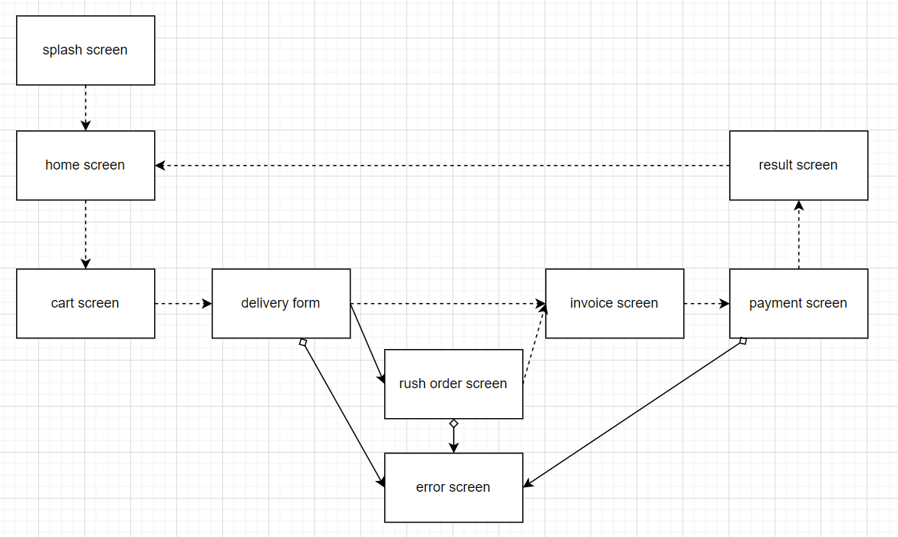

# Screen specification

**Splash Screen**

|  |  |  |  |  |  |
| --- | --- | --- | --- | --- | --- |
| **Aims Software** | | **Date of creation** | **Approved by** | **Reviewed by** | **Persion in charge** |
| **Screen specification** | **Splash screen** | 10/11/2022 |  |  |  |
|  | | **Control** | **Operation** | **Function** | |
| Main area | None | Loading | |

## 

## **Home Screen**

|  |  |  |  |  |  |
| --- | --- | --- | --- | --- | --- |
| **Aims Software** | | **Date of creation** | **Approved by** | **Reviewed by** | **Persion in charge** |
| **Screen specification** | **Home screen** | 10/11/2022 |  |  | Pham Hai Dang |
|  | | **Control** | **Operation** | **Function** | |
| AIMS image | Click | Return to home screen | |
| Search bar | Type and Click | Type name of search items and search | |
| Cart logo | Click | View items in the cart | |
| Main area | Click | Items info and add to cart | |

|  |  |  |  |  |
| --- | --- | --- | --- | --- |
| **Screen** | **Main screen** | | | |
| **Field name** | **Type** | **Limitation** | **Attribute** | **Remarks** |
| Media title | Text | 40 characters | Black | Left-justified |
| Price | Digits | 10 digits | None | Left-justified  Dot for thousand separation |
| Avail | Digits | 5 digits | None | Left-justified |
| Item image | Image | 163x128 pixels | None | None |

## **Cart Screen**

|  |  |  |  |  |  |
| --- | --- | --- | --- | --- | --- |
| **Aims Software** | | **Date of creation** | **Approved by** | **Reviewed by** | **Persion in charge** |
| **Screen specification** | **View cart screen** | 10/11/2022 |  |  | Pham Hai Dang |
|  | | **Control** | **Operation** | **Function** | |
| Area for displaying the subtotal | Initial | Display the subtotal | |
| Area for display items in the cart | Initial | Display the product with corresponding information | |
| Place order button | Click | Display the Delivery form | |
| Edit number button | Click/Input | Change number of selected products | |

|  |  |  |  |  |
| --- | --- | --- | --- | --- |
| **Screen** | **Cart screen** | | | |
| **Field name** | **Type** | **Limitation** | **Attribute** | **Remarks** |
| Media title | Text | 40 characters | Bold, black | Left-justified |
| Price | Digits | 10 digits | None | Left-justified  Dot for thousand separation |
| Subtotal |
| Currency | Text | 3 characters | All caps | None |
| Item thumbnail | Image | 163x128 pixels | None | None |

## **Delivery Form**

|  |  |  |  |  |  |
| --- | --- | --- | --- | --- | --- |
| **Aims Software** | | **Date of creation** | **Approved by** | **Reviewed by** | **Persion in charge** |
| **Screen specification** | **Delivery Form** | 10/11/2021 |  |  | Pham Hai Dang |
|  | | **Control** | **Operation** | **Function** | |
| Area for filling the name | Input | Fill name of the customer | |
| Area for filling phone | Input | Fill phone of the customer | |
| Area for filling address | Input | Fill specific address of the customer | |
| City selecting dropdown | Select | Change city of customer | |
| District selecting dropdown | Select | Change district of customer | |
| Area for filling shipping instruction | Input | Fill shipping instruction of the customer | |
| Checkbox for rush order placement | Select | Update the rush order status | |
| Submit button | Click | Save information and process to check rush order | |
| Cancel button | Click | Cancel the current order | |

|  |  |  |  |  |
| --- | --- | --- | --- | --- |
| **Screen** | **Deliver screen** | | | |
| **Field name** | **Type** | **Limitation** | **Attribute** | **Remarks** |
| Province/City | Select from list | None | None | None |
| District | Select from list | None | None | None |
| Rush order option | Checkbox | None | None | None |

## **Rush Order’s Additional Information**

|  |  |  |  |  |  |
| --- | --- | --- | --- | --- | --- |
| **Aims Software** | | **Date of creation** | **Approved by** | **Reviewed by** | **Persion in charge** |
| **Screen specification** | **Rush Order’s Additional Information** | 10/11/2022 |  |  | Pham Hai Dang |
|  | | **Control** | **Operation** | **Function** | |
| Area for inputting shipping detail | Initial | Update shipping detail | |
| Area for inputting delivery instruction | Input | Update the delivery instruction of order | |
| Area for selected expected delivery time | Select | Update the delivery expected time of order | |
| Confirm button | Click | Save information and process to invoice screen | |
| Cancel button | Click | Cancel the current order | |

## **Invoice Screen**

|  |  |  |  |  |  |
| --- | --- | --- | --- | --- | --- |
| **Aims Software** | | **Date of creation** | **Approved by** | **Reviewed by** | **Persion in charge** |
| **Screen specification** | **Invoice Screen** | 10/11/2022 |  |  | Pham Hai Dang |
|  | | Control | Operation | Function | |
| Area for displaying the selected address | Initial | Display the selected shipping address | |
| Area for displaying the customer’s phone number | Initial | Display the customer’s phone number | |
| Area for displaying the customer’s name | Initial | Display the customer’s name | |
| Area for displaying the customer’s instruction | Initial | Display the customer’s instruction | |
| Area for displaying the customer’s expected delivery time | Initial | Display the customer’s expected delivery time | |
| Area for displaying the shipping fee | Initial | Display the customer’s shipping fee | |
| Area for displaying the product list with specified info for each product | Initial | Display the customer’s product list | |
| Confirm button | Click | Save information and process to invoice screen | |

|  |  |  |  |  |
| --- | --- | --- | --- | --- |
| **Screen** | **Normal order invoice & Rush order invoice screen** | | | |
| **Field name** | **Type** | **Limitation** | **Attribute** | **Remarks** |
| Media title | Text | 40 characters | Bold, black | Left-justified |
| Price | Digits | 10 digits | None | Left-justified  Dot for thousand separation |
| Item total |
| Subtotal |
| VAT |
| Shipping fee |
| Total | Red |
| Currency | Text | 3 characters | All caps | None |
| Item thumbnail | Image | 163x128 pixels | None | None |
| Customer name | Text | 50 characters | Italic | None |
| Province/City | 30 characters |
| District | 30 characters |
| Address | 100 characters |
| Shipping instruction | 100 characters |
| Customer phone | Digits | 10 digits | Italic | None |

## **Payment Screen**

|  |  |  |  |  |  |
| --- | --- | --- | --- | --- | --- |
| **Aims Software** | | **Date of creation** | **Approved by** | **Reviewed by** | **Persion in charge** |
| **Screen specification** | **Payment Screen** | 10/11/2022 |  |  | Pham Hai Dang |
|  | | Control | Operation | Function | |
| Area for choosing the payment method | Click | Choose the payment method | |
| Area for filling card number | Type | Fill the card number of the customer | |
| Area for filling card holder | Type | Fill the holder of the card | |
| Area for filling the expiration date of the card | Type | Fill the expiration date of the card | |
| Area for filling security code of the card | Type | Fill the security code of the card | |
| Confirm payment button | Click | Confirm payment | |

## **Result Screen**

|  |  |  |  |  |  |
| --- | --- | --- | --- | --- | --- |
| **Aims Software** | | **Date of creation** | **Approved by** | **Reviewed by** | **Persion in charge** |
| **Screen specification** | **Result Screen** | 10/11/2022 |  |  | Pham Hai Dang |
|  | | **Control** | **Operation** | **Function** | |
| Area for displaying successful order | Initial | Display successful order | |
| Back | Click | Back to home screen | |
| Buy again | Click | Back to cart screen | |